Task 1: Concept Map
Create a concept map in draw.io, Lucidchart, Miro, Figma, or any suitable diagramming tool. The map must connect cloud ecosystem, cloud actors, service models, deployment models, virtualization, web services, REST/SOAP APIs, scalability, elasticity, and the students Project. 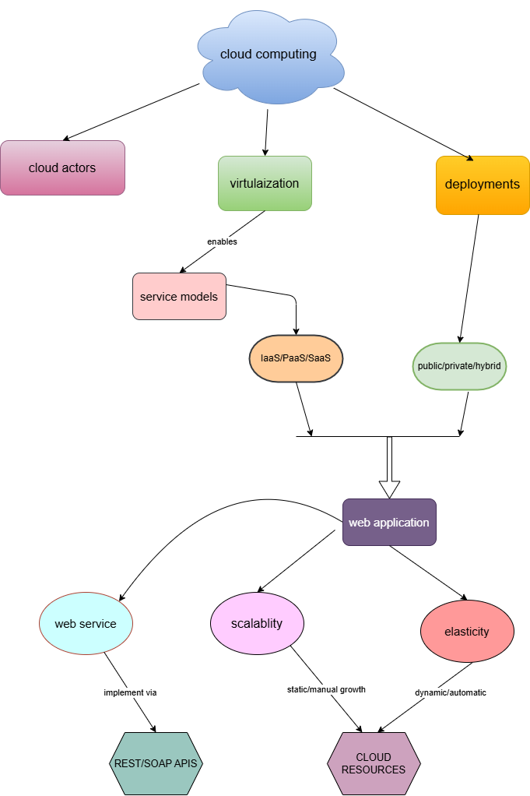

Task 2A: Service Model Responsibility Matrix
Prepare a technical matrix that compares SaaS, PaaS, IaaS, FaaS/serverless, database-as-a-service, storage-as-a-service, identity-as-a-service, and monitoring/logging services. For each selected service category, explain what is managed by the cloud provider, what is managed by the student application team, and why that split fits the Project.
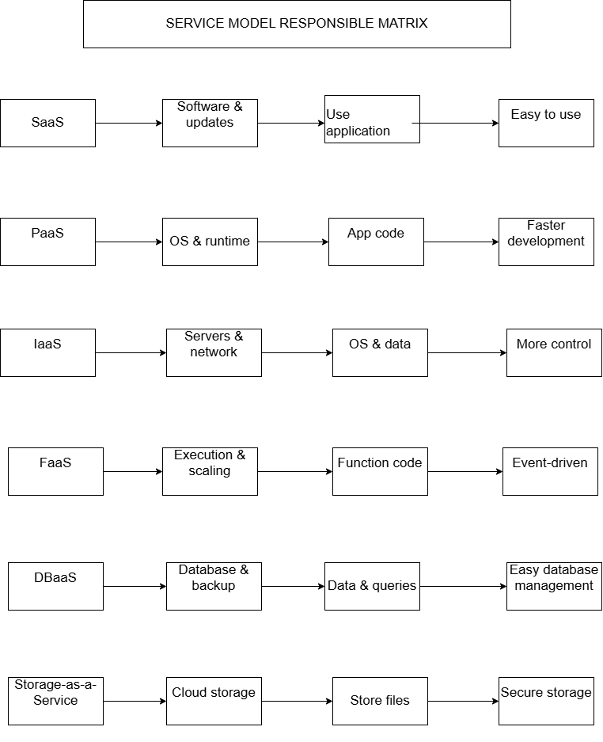
Task 3: API Flow, Elasticity, and Scalability Design
Draw a professional cloud-flow diagram for the Project modules. The diagram must show user app or web
app, API gateway/backend service, authentication, compute layer, database, object storage,

analytics/logging, monitoring, security boundaries, and scaling points. Students may replicate the given
visual pattern, but all components and labels must be customized to their own architecture.
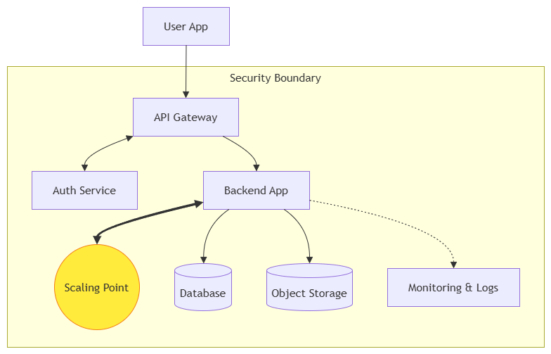
4. TECHNICAL JUSTIFICATION
Cloud service models such as SaaS, PaaS, and serverless are selected to reduce infrastructure management and improve scalability. APIs enable communication between frontend, backend, and AI modules, ensuring modular design. Elasticity allows the system to automatically scale resources based on demand, improving performance and cost efficiency. Virtualization and managed cloud services provide efficient resource utilization and reduce operational overhead. Responsibility is shared between the cloud provider and application team, ensuring security, reliability, and system efficiency.

- Evaluate the effectiveness of your concept map in representing cloud computing principles. Whichdesign decisions most strongly support your solution, and why?
The concept map effectively represents cloud computing by linking core components such as services, APIs, and scalability. The structured layout improves clarity and understanding.

2. Analyze how scalability, elasticity, and resource management influence the architecture shown in your concept map. What challenges could arise if these capabilities were absent?
Scalability and elasticity ensure the system can handle varying workloads. Without them, the system may face downtime, slow performance, and poor user experience.

3. Justify the selection of the APIs, web services, or cloud services included in your concept map. How do they contribute to the overall functionality and efficiency of the system?
APIs and web services enable communication between system components. REST APIs improve flexibility, integration, and efficiency.

4. Critically examine the relationships between the components in your concept map. How do these interactions improve reliability, performance, or user experience?
Component interactions improve system reliability and performance by ensuring smooth data flow and reducing delays.

5. Reflect on the process of developing your concept map. How has creating and analyzing the map changed your understanding of cloud computing architecture, and what improvements would you make if you were redesigning it?
Creating the concept map improved understanding of cloud architecture. Future improvements would include more detailed layering and clearer relationships.

